JOAN CARLES AMAT

GUITARRA ESPANOLA

Joan Carles Amat was born in about 1572 in Monistrol de Monserrat, a small town near Barcelona and the Monastery of Monserrat. He was the son of Joan Carles and Joana Amat; his principal surname, by which he seems to have been known in his lifetime, is therefore Carles. The Catalan spelling is Joan Carles Amat, and the Castilian, Juan Carlos Amat, but it is not consistently spelt in any of the original sources. Today he is usually referred to as Amat.

He studied medicine at the University of Valencia, graduating in about 1595. In 1600 he married Monica Ubach Casanovas but they had no children. After graduating he seems to have spent some time in Lérida. Later he became medical officer of Monistrol and physician to the monastery. He also held various civic offices in the town. He died in Monistrol on 10 February 1642 and was buried in the parish church although his grave is no longer visible.

His treatise on the five-course guitar was first printed in Barcelona in 1596; no copies of this edition are known to survive. The earliest known copy is one printed in Lérida in 1626, now in the Newberry Library, Chicago. This reproduces the Aprobacion and Imprimatur of the Bishop of Barcelona, dated 15 June 1596 and 5 July 1596 respectively, and Amat’s letter dedicating the work to Juan de Agua Viva y Tamarit dated 10 August, 1596, from the original edition. The 1626 version was reprinted in Lérida in 1627; there is a copy in the Biblioteca Nacional, Madrid. This includes the letter of dedication, but not the Aprobacion and Imprimatur. In 1639 a new edition of the work was printed in Barcelona; there is a copy in the Biblioteca Marucelliana, Florence. This includes the Aprobacion and Imprimatur dated 1596, but not Amat’s letter of dedication. Instead it has a letter addressed to Amat by Leonardo de San Martín, dated 30 April 1639; this gives the date of the first edition as 1586 – probably a misprint. There were at least two further seventeenth century editions printed in Barcelona, in 1640 – a copy is in the library of the Hispanic Society of America, and in 1674 – in 1918 a copy was listed as being in a private collection. Both include the Aprobacion, Imprimatur and Amat’s letter of dedication.

Seventeenth century copies comprise nine chapters in Castilian (Spanish). During the eighteenth century the book was issued with a supplement of five chapters entitled “Tractat breu”; this is in Catalan or Valencian according to the place of printing. This may not be by Amat. The earliest copy at present known to include the “Tractat breu” was printed in Barcelona in 1701; the location is not yet traced. Eighteenth century copies do not have the author’s name on the title page and are often undated. They include the letter of Leonardo de San Martin, but not the Aprobacion or Imprimatur. They have often been wrongly dated 1639 on the basis of San Martin’s letter, and the date of the original edition cited as 1586 on the same basis. The book was still being reprinted at least as late as 1780.

The translation of the main part of the work is based on the 1626 edition. This is followed by the title page and letter of Leonardo de San Martin from the 1639 edition and the title page of the edition printed by Joseph Brò c.1761. The translation of the “Tractat breu” is based on the Catalan version included in the Joseph Brò edition. The illustrations are from the Joseph Brò edition.
THE FIVE-COURSE SPANISH GUITAR :

Which shows how to tune and how to play all the major and minor chords rasgado in a wonderful manner.

AND SO THAT ANY SONG CAN BE PLAYED ON IT,
a table is included with which
anyone may cipher a song, and afterwards play
and sing it without difficulty in twelve keys; newly added
by the author himself.

AND AT THE END MENTION
is also made of
the four-course guitar.

Dedicated to the Illustrious Señor Don Juan de Agua Viva y Tamarit,
Señor of the town of Salamo
and of the castle and establishment [quadro] of Agua Viva.

AUTHOR OF THIS METHOD, JOAN
Carlos Doctor of Medicine.

With a Licence printed in Lérida in the house of the Widow
Anglada and Andreu Llorens in the year 1626.

Sold at the same printers

I, Jayme Castellar, Prior of St. Anna in Barcelona, at the command of the very Illustrious and Reverend Monsignor Don Ioan Dymas Loris, Bishop of Barcelona, saw this book called Spanish Guitar by Doctor Joan Carlos, and I have not found in it anything contrary to the art of music; rather it contributes much to its perfection. And so it seems to me that it ought to be printed, so that all may make use of it. In Barcelona, 15 June 1596.

And P. Aegidius, Priest of the Society of Jesus, comissioned by the Bishop of Barcelona, finds nothing in it which is repugnant to the morals of the faithful.

We, Joan Dymas Loris, by the will of God and the Holy Apostolic See, Bishop of Barcelona, etc. having seen the above recommendation bestow a licence for the printing and distributing of this book here in our diocese. Given in the episcopal palace in Barcelona, 5 July, 1596.

TO THE ILLUSTRIOUS
Señor Juan de Agua Viva, y Tamarit, Señor of the town of Salamo and of the castle and estate of Agua Viva.

Illustrious Sir: That great sovereign, prince of the philosophers, Aristotle, shows us how natural man delights in hearing music and poetry when in the first book written about poetry which he left us, he says “homo naturaliter delectatur symphonia et metro”; and not only man, but also the animals seem to delight in hearing any instrument. There is no reason to dismiss this sentence, for it is also subscribed to in Spain, and Spanish sensibility delights in nothing more than in the sound of the guitar.

As a result of your grace’s patronage (and because many of my friends have commanded me to do it), I have desired to publish that which follows only so that musicians may be able to play and sing easily with order and without confusion, accepting it in the spirit in which I offer it.

May Our Lord preserve your grace for many years with the increase of much status, as he is able. Monistrol, 10th August, 1596.
Doctor Juan Carlos.

TO THE READER

Discriminating reader, the choleric temperament of Spain has been the principal cause of this little work seeing the light of day, as I see that nothing is more necessary than that one should be phlegmatic in order to teach the art of playing the guitar, and so those who desire to be instructed in this should not be surprised if after three days their teachers are worn out with teaching them. For the choleric humour has so opressed all Spaniards, that anything we undertake, no matter how brief, seems to us very lengthy. So bearing in mind the lack that there is in the whole of this country, because no author has written about it (at least to my knowledge), I wished to write about the tuning and playing rasgado of this five-course guitar, called Spanish because it is more welcome in this country than in others, and about the method of arranging any piece of music for it, in such a way that it might serve as a teacher, and also so that students of the instrument need not be subjected to as much misery as that which our humour predisposes us to.

I would like to ask all those who may use this book of mine to consider that the cause of it all has been good will. And I beg them humbly and for the love of God, not to use it except to praise and serve our Saviour Jesus Christ and the Blessed Virgin Mary, his mother, singing canciones like those which are sung on the feast of the Nativity of Our Lord, and on the feast and octave of the Blessed Sacrament [Corpus Christi], and on all the feasts of Our Lady. For the intention which I have, and have always had, has been that all the Saints may be praised, and especially the saint of saints, Our Lady of the Rosary, and the Forerunner, St. John the Baptist, my patron saint, whom I beseech to intercede for me before God, so that I and all Christians may attain the Life Eternal. Amen.

FROM MONSERRATE BASTUS TO THE AUTHOR

SONETO

Muses who on Parnassus are seated,
Your skirts full of various flowers,
Making and composing garlands,
Which are so many times begun;

If they are, which is possible, engarlanded,
With a thousand beautiful hyacinths, and painted,
on the brow of Carlos, employed
on it alone, they are well employed.

If Carlos to the high sounding lyre
Of Apollo orders his accents,
With admirable style and pleasing manner

The ninefold choir is right, that sings
Praises of such high thoughts
Giving it with reason, of all, its all.

FROM HIERONYMO TRIAS TO THE AUTHOR

SONETO

Those whom Orpheus carried behind him,
At the time that he was playing his instrument
Are able to come lightly like the wind
If they wish their good desire to go forth.

With great title, and more recreation
With more power, and more merit
They can come running in pursuit
of Carlos, like the boy to Galatea.

Today Carlos can in this be immortalized,
He alone sings a tune well ciphered
And Carlos kills the song of Cicharra.

Whoever knew Carlos may be named
Fortunate, enriched in highest grade,
And even more, he who heard him with his guitar.

THE GUITAR
TO THE READER
SONETO

I am all that about which I sing,
I am Queen of the delightful tunes
I am that which cheers all beings
And I am that which condemns the sad lament.

I have five sons, amongst whom
When they come through my gardens and my meadows,
I harmonize games so joyful
That to Phoebus himself at times I cause dismay.

If you wish to see (Reader) the gracefulness
That Carlos gave me, I being in his care,
Taste the broth which his spoon gives.
You will see that I am gay, guarded, guided
gracious, galant, graceful, genteel
goluptious, general, gratifying, guitar.

The Author, speaking with one of his brothers, teaches him how to play the guitar, and so the work begins.

CHAPTER 1
In which is explained how many strings and frets there are on the guitar, and the way of tuning them

This five-course Spanish guitar which you have in your hands (my brother) has nine strings in all, one on the first course, called first, and two on the rest of the courses, which are called seconds, thirds, fourths and fifths. The seconds and thirds have their strings tuned in unison; but the fourths and fifths, having one thicker string on each course, are not tuned in unison in the way that the seconds and thirds are, because the thicker ones are tuned an octave lower than the strings which accompany them.

No more than four frets will be necessary, because the chords which can be formed at the rest [of the frets] have the same sound as those which we form at the second, third and fourth frets, as we will explain later.

Now as this is very necessary, we are going to tune [the instrument], which is done like this

First of all, you will take the thirds, that is, the third course, tuned in unison and stopped at the second fret, and with them you will tune the fifths, the thinner one in unison, and the thicker one an octave lower than its companion. And then stopping the fifths at the second fret, you will tune the seconds, tuning them in unison. Then you will take these seconds stopped at the third fret and you will tune the fourths with them so that the thinner one is in unison, and the thicker one an octave lower than its companion. And stopping the fourths at the second fret, you will tune the first, which is the first course, in unison as well. And in this way the guitar will be tuned throughout. Musicians are accustomed to tune in many ways, but in the end all is the same, because starting with the fifths or the fourths, or any of the other courses, observing the above-mentioned, all is the same thing.

This is the method of tuning, which is so difficult to many, so easy to those who have a little natural ability and know how to sing. And there are men, who without knowing much about solmization, tune, play and sing better with their great talent, than those who have spent all their lives in chapel choirs. This ability is inate, [but as] this is not the place to speak of it, I will leave it to those who have discussed the matter at length. What I wish to say is that this guitar can only be understood by those of good understanding.

CHAPTER 2

What is a chord, how many there are and how they are named

As you now have the guitar tuned and ready to play, it is right to show you next what sort of thing a chord is, how many there are and what they are called.

First of all, the guitar chord is an arrangement made by the fingers stopping the strings behind the frets. Each chord has its different pattern and arrangement, and each has three different voices, which are the bass, alto and treble [root, third and fifth]. There are only twenty four of these (leaving out diminished or augmented chords, and discords [semitonados y falsos], as these are not important for our purpose). Twelve are major [naturales], and twelve are minor [b mollados]; the minor do not differ from the major except for [the note on] one string and this string is minor [i.e. a minor third].

These chords are referred to in many ways, such as cruzado mayor, cruzado menor, vacas altas, vacas baxas, puente, and in inummerable other ways as musicians, one and another have given them different names. But here I shall call them only first, second, third and fourth etc., qualifying them as either major or minor.

CHAPTER 3

Of the arrangement of the major chords

In Chapter 3 it is necessary to describe the way in which major chords are arranged, each one in turn, so that you may be able to play them better.

Chord 1n is formed by placing a finger of the left hand (I refer to the left hand, as few people play the other way round), on the third course at the first fret, another on the fourth course at the second fret, and another on the fifth course at the second fret; and the two remaining courses, the first and the second, are not stopped with any finger, but are left open. In this chord, the root is on the fourth course, the third on the third course and the fifth on the second course. The first course is the same as the fourth, and the fifth as the second. [E major]

Chord 2n is formed placing a finger on the second course, another on the third course, and another on the fourth course all at the second fret; and the first and the fifth remain open. The root of this chord is on the fifth course, the third on the second course and the fifth on the first course; the fourth course is the same as the first, the third the same as the fifth. [A major]

Chord 3n is formed placing a finger on the first course at the second fret, another on the second course at the third fret, and another on the third course at the second fret; and the fourth and the fifth remain open in this chord. The root is found on the fourth course, the third on the first course and the fifth on the third course; the second course is the same as the fourth, and the fifth the same as the third. [D major]

Chord 4n is formed placing a finger on the first course, and another on the second course at the third fret, and another on the fifth course at the second fret; and the third and the fourth courses remain open. The root is found on the third course, the third on the fifth course and the fifth on the fourth course; the first course is the same as the third, the second the same as as the fourth. [G major]

Chord 5n is formed placing a finger on the first course at the third fret, another on the second course at the first fret, another on the fourth course at the second fret and another on the fifth course at the third fret; only the third course remains open. The root is on the fifth course, the third on the fourth course and the fifth on the third course; the first course is the same as the third, the second the same as as the fifth. [C major]

Chord 6n is formed placing a finger on the first course and another on the second course at the first fret, another on the third course at the second fret, another on the fourth course and another on the fifth course at the third fret. In this chord no course remains open. The root is found on the fourth course, the third on the third course and the fifth on the second course; the first course is the same as the fourth, the fifth the same as the second. [F major]

Chord 7n is formed placing a finger on the first course at the first fret, another on the second course, another on the third course, another on the fourth course [all] at the third fret; and another on the fifth course at the first fret; none are left open. The root is found on the fifth course, the third on the second course and the fifth on the first course. The fourth course is the same as the first, the third as the fourth. [B flat major]

Chord 8 is formed placing a finger on the first course at the third fret, another on the second at the fourth fret, another on the third course at the third fret, another on the fourth course and another on the fifth course [both] at the first fret. The root is found on the fourth course, the third on the first and the fifth on the third. [The fifth course is the same as the third and the first as the fourth]. [E flat major]

Chord 9n is formed placing a finger on the first course and another on the second course at the fourth fret, another on the third course and another on the fourth course at the first fret, and another on the fifth course at the third fret. The root is found on the third course, the third on the fifth course, and the fifth on the fourth course. The first is the same as the third course, the second as the fourth. [A flat major]

Chord 10n you will form placing a finger on the first course at the first fret, another on the second course at the second fret, another on the third course at the first fret, another on the fourth course at the third fret, and another on the fifth course at the fourth fret. The root is found on the fifth course, the third on the fourth course, and the fifth on the third course; the first is the same as the fourth course and the second as the fifth. [C sharp major]

Chord 11n is formed placing a finger on the second course and another on the first course at the second fret, another on the third course at the third fret, another on the fourth course and another on the fifth course [both] at the fourth fret. The root is found on the fourth course, the third on the third course, the fifth on the second course. The first is the same as the fourth course, and the fifth as the second. [F sharp major]
Chord 12n, the last, must be formed placing a finger on the first course, and another on the fifth course at the second fret, another on the second course, another on the third course, and another on the fourth course [all] at the fourth fret. The root is found on the fifth course, the third on the second course, and the fifth on the first course; the fourth is the same as the first course, the third as the fourth. [B major]

CHAPTER 4

Of the minor chords

Now that you understand the major chords, it is necessary to describe the minor ones, which are these.

Chord 1b is formed placing a finger on the fourth course and another on the fifth course at the second fret, and the three courses which are the first, second and third courses are left unstopped. The root is on the fourth course, the third on the third course and the fifth on the second course. The first course is the same as the fourth course and the fifth as the second. In this chord the minor third is found on the third course. [E minor]

Chord 2b is formed placing a finger on the second course at the first fret, another on the third course and another on the fourth course at the second fret and the first and fifth courses are left unstopped. The root is on the fifth course, the third on the second course and the fifth on the first course. The fourth course is the same as the first course and the third as the fifth. The minor third is on the second course. [A minor]

Chord 3b is formed placing a finger on the first course at the first fret, another on the second course at the third fret and another on the third course at the second fret and the first and fifth courses are left unstopped. The root is on the fourth course, the third on the first course and the fifth on the third course. The second course is the same as the fourth course and the fifth as the third. The minor third is on the first course. [D minor]

Chord 4b is formed placing a finger on the first course at the third fret, another on the second course at the third fret and another on the fifth course at the first fret and the third and fourth courses are unstopped. The root is on the third course, the third on the fifth course and the fifth on the fourth course. The first course is the same as the third course and the second as the fourth. The minor third is on the fifth course.
[G minor]

Chord 5b is formed placing a finger on the first course at the third fret, another on the second course and another on the fourth course at the first fret and another on the fifth course at the third fret and the third course is unstopped. The root is on the fifth course, the third on the fourth course and the fifth on the third course. The first course is the same as the third course and the second as the fifth. The minor third is on the fourth course. [C minor]

Chord 6b is formed placing a finger on the first course, another on the second course and another on the third course at first fret, another on the fourth course, and another on the fifth course at the third fret. No course is unstopped. The root is on the fourth course, the third on the third course and the fifth on the second course. The first course is the same as the fourth course and the fifth as the second. The minor third is on the third course. [F minor]

Chord 7b is formed placing a finger on the first course and another on the fifth course at the first fret, another on the second course at the second fret, another on the third course and another on the fourth course at third fret. The root is on the fifth course, the third on the second course and the fifth on the first course. The fourth course is the same as the first course and the third as the fifth. The minor third is on the second course. [B flat minor]

Chord 8b is formed placing a finger on the first course at the second fret, another on the second course at the fourth fret, another on the third course at the third fret, another on the fourth fret, and another on the fifth course at the first fret. The root is on the fourth course, the third on the first course and the fifth on the third course. The second course is the same as the fourth course and the fifth as the third. The minor third is on the first course. [E flat minor]

Chord 9b is formed placing a finger on the first course, another on the second course at the fourth fret, another on the third course, another on the fourth course at the first fret, and another on the fifth course at the second fret. The root is on the third course, the third on the fifth course and the fifth on the fourth course. The first course is the same as the third course and the second as the fourth. The minor third is on the fifth course. [A flat minor]

Chord 10b is formed placing a finger on the second course at the second fret, another on the third course at the first fret, another on the fourth course at the second fret and another on the fifth course at the fourth fret, and the first is unstopped. The root is on the fifth course, the third on the fourth course and the third on the third course. The first course is the same as the fourth course and the second as the fifth. The minor third is on the fourth and first courses. [C sharp minor]

Chord 11b is formed when a finger is placed on the first course, another on the second course, another on the third course all at the second fret, another on the fourth course and another on the fifth course at the fourth fret. The root is on the fourth course, the third on the third course and the fifth on the second course. The first course is the same as the fourth course and the second as the fifth. The minor third is on the third course. [F sharp minor]

Chord 12b, the last chord, is formed placing a finger on the first course, another on the fourth course [sic - actually the fifth course] at the second fret, another on the second course at the third fret, and another on the third and another on the fourth course at the fourth fret. The root is on the fifth course, the third on the second course and the fifth on the first course. The fourth course is the same as the first course and the third as the fifth. The minor third is on the second course. [B minor]

Observe that although in the foregoing [description of] both major and minor chords I refer to each chord as having a bass, alto and treble, each one on its string, nevertheless I concede that sometimes they are changed from one string to another, so that sometimes the bass is on the alto or treble string, and the alto on the treble or bass sstring, and the treble on the alto or bass string. And observe too that although I say that three different notes are found in each chord, nevertheless I concede that many others may be joined together in each chord, as we will explain later. And observe as well that in some places you will find that I say strings instead of courses, and in others courses instead of strings; although the names are different, both mean the same thing.

[The wording of the descriptions of the chords varies slightly but has been standardized in the interests of simplicity].

CHAPTER 5
About the table showing with which finger and at which fret the string has to be stopped

What has been said so far about the chords will not be of much use to you unless you are now shown which fingers to use to stop the string with when playing each chord. For when it says put one finger, and another, without specifying which one you should use to stop [the string] with, it will be difficult for you as a beginner, to fit your fingers to the chords if you do not know how to make the appropriate patterns. Because in some chords one finger by itself is used to stop two strings, and in many three, I feel that it would be almost impossible to explain them. And so to avoid all this, I would now like to describe a method of understanding all that has been said previously by means of the table below, with which you will be able to work out easily not only which finger you should use to stop the string with, but also at what fret. This is the table.

[Circular diagram]
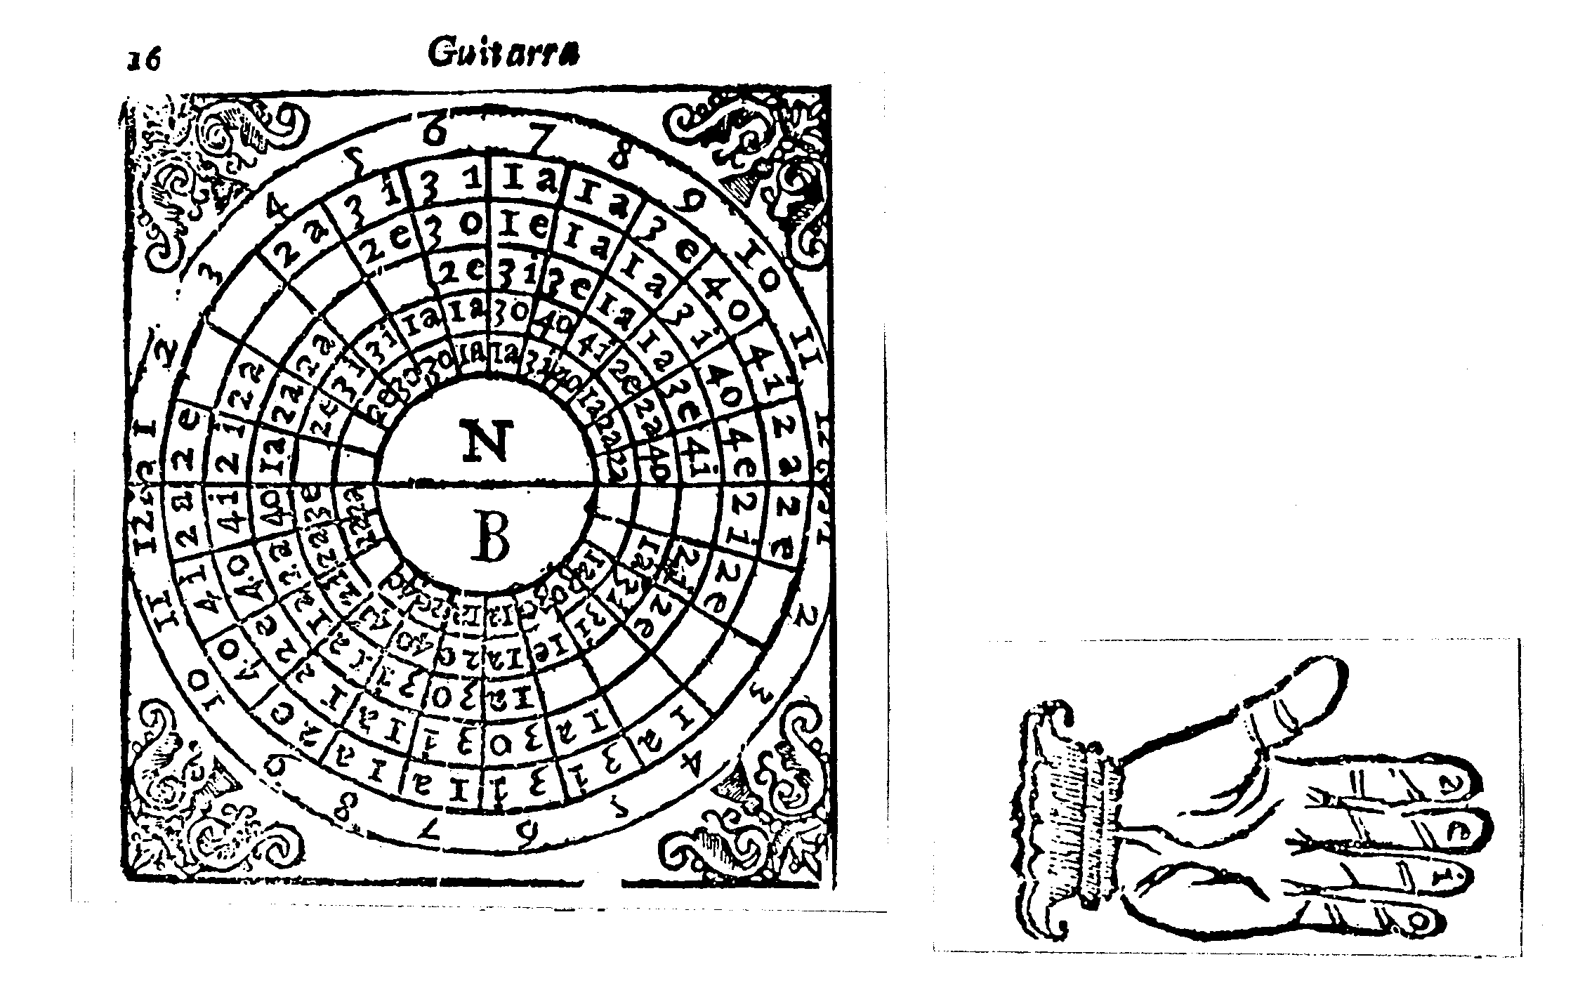

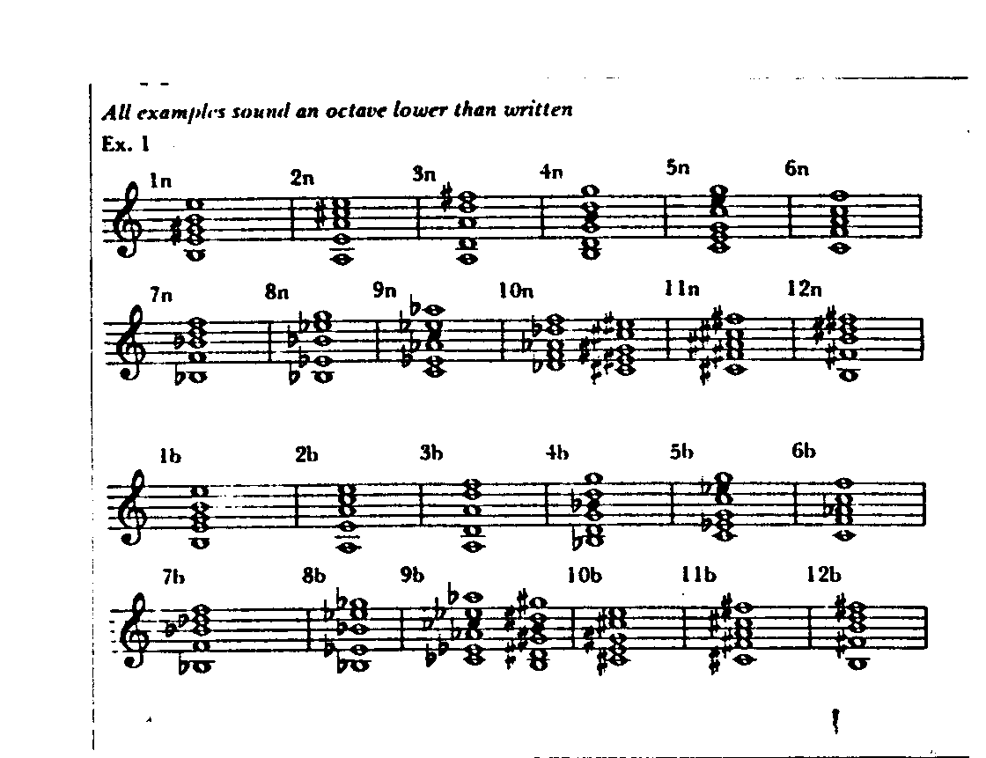

Explanation of the table

To explain the table properly, we need to think in terms of division, beginning with the whole, proceding to the parts, and finally to the smaller parts. First the table as a whole is divided into two parts, one labelled N, and the other, B. The letter N indicates the part in which all the major chords are situated, and the letter B that where the minor chords are situated.

Each of these two parts is divided into twelve smaller parts, each one of which represents a chord; if this is the part labelled N, it represents a major chord, and if in the part labelled B, a minor chord.

For each chord, whether major or minor, there are five spaces, which represent the five courses of the guitar in the following manner. The space nearest the centre represents the first course, that next to it, the second course, that in the middle, the third course, the next one, the fourth course, and the last (which is the furthest from the centre) the fifth course.

Within these spaces are placed first the numbers which indicate the frets of the guitar, and then letters which indicate the fingers of the hand with which we stop the strings. The numbers are 1,2,3,4; the one represents the first fret, the two the second fret, the three the third fret and the four the fourth fret. The letters are a, e, i, o. The a indicates the finger nearest the thumb, called the index finger in Latin. The e indicates the longest [middle] finger, called infamis or famosus. The i indicates the finger next to the little finger [ring finger], called medicus or anullaris. The o indicates the little finger, called minimus, or auricularis, as is illustrated by this hand.

[Illustration of the hand]

When you wish to play one of the major or minor chords, taking the guitar, you will place the finger indicated by the letter, on the string represented by the space, at the fret indicated by the number, and in this way you will be able to form any chord quickly and without difficulty.

Now that the table has been explained in full, I would like to give two examples, one of a major chord and the other of a minor one, so that you may understand it better.

This is the first example. In chord 3n [D major] we find in the space nearest the centre, (which represents the first course) the number 2 and the letter e; in the second space the number 3 and the letter i; and in the third space the number 2 and the letter a; which means that to form chord 3n you have to put the middle finger on the first course at the second fret, the ring finger on the second course at the third fret, and the index finger on the third course at the second fret. There are no numbers or letters in the two remaining spaces (which represent the fourth and fifth courses), and so for this chord no fingers are place on the fourth and fifth courses.

Chord 7b [B flat minor] may be taken as the other example, and in this we find in the first space the number 1 and the letter a; in the second space the number 2 and the letter e; in the third space the number 3 and the letter o, in the fourth space the number 3 and the letter i; and in the fifth space the number 1 and the letter a; which means that to form chord 7b you have to put the index finger on the first course and the fifth course at the first fret [i.e. a barré at the first course], the middle finger on the second fret of the second course, the little finger on the third fret of the third course and the ring finger on the third fret of the fourth course.

CHAPTER 6

How there are no more than twelve major and minor chords

All the chords which can be played on the guitar are placed in the aforementioned table, and if anyone says that there are others, such as those which are formed at the fifth, sixth, seventh or other frets, take my word for it, all these have the same consonance and the same root [or name] as those which we have already described, because chord 13, which follows chord 12 has the same consonance and root as chord 1, chord 14 is like chord 2, chord 15 like chord 3 etc. It was for this reason that I said at the beginning of chapter 1 that four frets are enough for playing the guitar, since chords which are formed at the fifth, sixth, seventh etc. frets are the same as those formed at the first, second, third and fourth.

This can easily be proved by reasoning. If the root is found to rise a [perfect] fourth, that is, from UT to FA, from chord 1 to chord 2, and from chords 2 to 3 another fourth, and from chords 3 to 4 another fourth, and so on rising from one to another as far as chord 12; and if from chord 1 to chord 12 we find only the same [interval of a perfect] fourth as we found from chord 12 to chord 13, it stands to reason that chord 13 is the same as chord 1, and likewise chord 14 is the same as chord 2, chord 15 the same as chord 3 and so on for all the rest, because the distance rising from one chord to another is a fourth. There is no need to prove this, as it is so obvious. All that we have said is to be understood both for major chords and minor chords, so that if 13 is major, it will have the same consonance as 1n, and if it is minor, it will be the same as 1b.

Since we have touched on this matter – that there is a fourth, encompassing four notes of the hexachord, rising from one chord to another, I would like to mention some other things which will be useful in connection with that which we will be discussing.

If you wish to ascend from UT to RE [i.e. a tone], starting from any of the twelve guitar chords, you must go back two chords, so that if you find yourself on chord 4 [=G] with the note UT and you wish to ascend next to RE, you have to take chord 2 [=A]; then if after the note RE you wish to ascend to MI, you have to take chord 12 [=B], which is the one which follows chord 1 when moving backwards, because if chord 1 follows chord 12 when moving forwards, chord 12 will follow chord 1 when moving backwards.

In this way you have to ascend from one note to another, moving back two chords, except when rising from MI to FA, or from LA to FA [i.e. a semitone] and then you must not move back two chords, but forward five. For example, if you find yourself on chord 1 [=E] with the note MI, or LA, and you wish to ascend next to FA, you have to take chord 6 [=F]. Also when you find that you have to ascend a semitone [sustentado], you have to go to work in the same way, moving forward the same number of chords.

And when you find the note FA, and the note descends next to another FA [i.e. descends a tone, mutating to the hexachord transposed up a fourth?] then you will move forward two chords, as for example, if being on chord 6 [=F] with the note FA, it is necessary to descend next to another FA, you will use chord 8 [=E flat].

You must understand that what I have said about ascending works the opposite way round when descending.

CHAPTER 7

From the chords all manner of pieces [tonos] can be played in twelve different keys

All that has been discussed so far is, as it were, the material from which many forms can be created. The good and skilful painter has prepared all the colours which are needed for painting, from which he choses as he pleases, whether he wishes to paint a man, a lion or a bull. In the same way, we have so far prepared all the chords, which are as it were, our material, and like the painter’s colours, from which all sorts of pieces can be created, skipping from one to another.

With these chords you can create various passeos, gallardas, villanos, Italianas, pavanillas and other similar pieces in twelve keys [ en doze partes]. And what is more remarkable (and what seems impossible to many) is that with these chords anyone can arrange or accompany anything that is played in these same twelve keys, and can play with any other musical instrument. I could say many other things at this point about the usefulness of the guitar, but for many reasons, it is not convenient for me to do so. Those who know the truth of the matter, of whom I think there will be many, may say them for me.

I will explain here how and in what way the passeo, which is common around here, may be played in any of the twelve keys, (and in such a ways as to comply with every kind of understanding). So that understanding this, and that which we will describe afterwards, you will easily be able to play anything with all the twelve chords. This passeo to which I refer is composed of three chords, one of which is played twice, and two of which are played only once. And as it can be played in twelve keys, let us start with the first one.

The first is made when we play chord 1, and from this we go to chord 2, and then to chord 12 and then to chord 1 again.
The second is made when we play chord 2, and from this we go to chord 3, and then to chord 1 and then to chord 2 again.
The third is made when we go from chord 3 to chord 4, and from this to chord 2 and we return to chord 3 again.
The fourth is made from chord 4 to chord 5, after to chord 3, and again to the same chord 4.
The fifth is when it goes from chord 5 to chord 6, and from this it descend to chord 4 and returns to chord 5.
The sixth is to leave from chord 6 and procede to chord 7, and from this to go to chord 5, and then return to chord 6.
The seventh is when we go from chord 7 to chord 8, and from this to chord 6, and then we return to chord 7.
The eighth is to go from chord 8 to chord 9, and from this to chord 7, and then to return to chord 8.
The ninth is when it goes from chord 9 to chord 10, and from this to chord 8, and then it returns to chord 9.
The tenth is when it goes from chord 10 to chord 11, and after it goes to chord 9, and then returns to chord 10.
The eleventh is made when we go from chord 11 to chord 12, and from this to chord 10, and we return again to chord 11.
The twelfth and last is made when we play chord 12, and from this we go to chord 1, and after to chord 11, and the we return to chord 12.

[The chord progression is I IV V I, major or minor; Amat does not distinguish between the major and minor chords]

I wanted to describe these twelve ways of performing the passeo because it is common to such a lot, almost an infinite number, of pieces; and also because once you know how to transpose it from one key to another, you will know how to play many of the little pieces which which are popular around here, such as vacas, gallardas, pavanillas, sezarillos etc. in twelve different keys. And so as not to weary you by describing them one by one, I will place here below as an example some vacas in ciphers.

Vacas

1 12 10 9 1 12 10 9 10
2 1 11 10 2 1 11 10 11
3 2 12 11 3 2 12 11 12
4 3 1 12 4 3 1 12 1
5 4 2 1 5 4 2 1 2
6 5 3 2 6 5 3 2 3
7 6 4 3 7 6 4 3 4
8 7 5 4 8 7 5 4 5
9 8 6 5 9 8 6 5 6
10 9 7 6 10 9 7 6 7
11 10 8 7 11 10 8 7 8
12 11 9 8 12 11 9 8 9

[The chord progression is III VII i V III VII i V I – i.e. that of the romanesca; Amat does not distinguish between the major and minor chords]

Now that you understand (my brother) how the little piece above is played in twelve keys, each one different, and not only this, but also that you may play all of them in this way, perhaps you are wondering why it is necessary to know how to play in so many keys, and why it is not sufficient to know only one way, since they all have the same sound, and it is no easy matter to remember them all. In reply to what you ask, be guided by me, and I would say that there are two reasons why it is useful to know how to play each piece using any of the chords.

The first is this. As you know, the voice cannot adapt itself to all the chords, because some have a high voice, and others a low one. And if you want to sing with a guitar, which may itself be pitched very high or very low, in a key which you know and are sure of, and you do not know how to play the music which you wish to sing except in one way, it stands to reason that you will have to sing it either too high or too low, and you will offend your own sensibilities and those of your listeners. But if you know how to play the piece in the twelve different keys, you will be able to sing it at a pitch which suits your voice, whether the guitar is very high or very low.

The second reason is that when you want to play duets for two guitars, when one instrument is very high and the other very low, you will be able to play [actually cantar - to sing] in consort with your companion, for even if the chords are different, it will all sound the same. In this way, twelve guitars could play together, each one according to its pitch, and all would make the same sound.

CHAPTER 8

Of a table with which anyone can cipher a piece of music [tono] and sing in the twelve keys [modes].

What we are going to discuss now will be as useful as that which has already been described; but you will need to understand all that we have talked about so far, in order to understand what we are going to say here. And I should like to point out to you, that to arrange any piece of music for guitar it is not necessary to understand the table which you will see here, because you can still arrange any piece of music you like without it. But this will be as difficult, as doing it the way which you will see now is easy.

To confirm this I would like to tell you about an encounter I had with some guitarists, four in number, who posed as the foremost in Spain in the art of arranging and accompanying, and who (there were four of them) were the best of their kind [saneados], and they knew very well that I had a certain device with which I could immediately arrange any piece of music for guitar.

I found myself passing an evening with them, and one of them said to me with all due respect,

“My friend, we understand that you know a wonderful art with which you can quickly arrange any piece of music for the guitar.” (And they did this to make fun of me, as they admitted afterwards). “My companions and I (who wish to follow your example) beg you to show us the method that you have, and the system which you use for doing that of which we have spoken. And if you do this, we will be satisfied, and we will make it a precedent, so that in other things we may be able to follow your example as well.”

Thinking this as likely as seeing flowers in winter, and understanding the plot without letting them know that I understood it, I replied,

“Gentlemen, the method of doing this which I have is of little importance, and in your presence would seem like a grain of mustard placed beside a great mountain. May you be with your riches, and I with my poverty.”

Dissatisfied with my reply, they asked me afresh, and saying that it was a very little thing, I showed them no sign of wishing to explain it to them. Finally they said,

“Friend, in so far as the system you have may be used for arranging three parts only, what you say may be true, but we are sure that it is false and an impossible thing, that it could be used for more. And be assured that, the opportunity having arisen, we have come here, only to say this to you.”

Without displaying any perturbation of spirit I said to them,

“Gentlemen, the truth is this. I have a system of which you speak in the form of a little table, which I invented (although some have pirated it), and with it not only three, but four, five, six or as many parts as you wish may be arranged for guitar. And so that you may understand that what I am saying is the truth, let us go wherever you wish to make an experiment and you will see that what I am saying is the truth.”

And they were content, thinking that it would be a better occasion for making fun of me. And we went to the apartment of one of them who was studying the arts, and going inside, they gave me some pages of music in five parts by Palestrina. And when I had ciphered the whole piece, they gave me a guitar, and we began to sing, each one his part, together with the instrument. And they saw that what I had promised them was true, so that, admiring what was done, and looking at one another, they were left as if with a platter without a partridge.

Thus, returning to our proposition, that it will be a very easy matter to do that which to many seems impossible by means of the promised table. Here is the table:

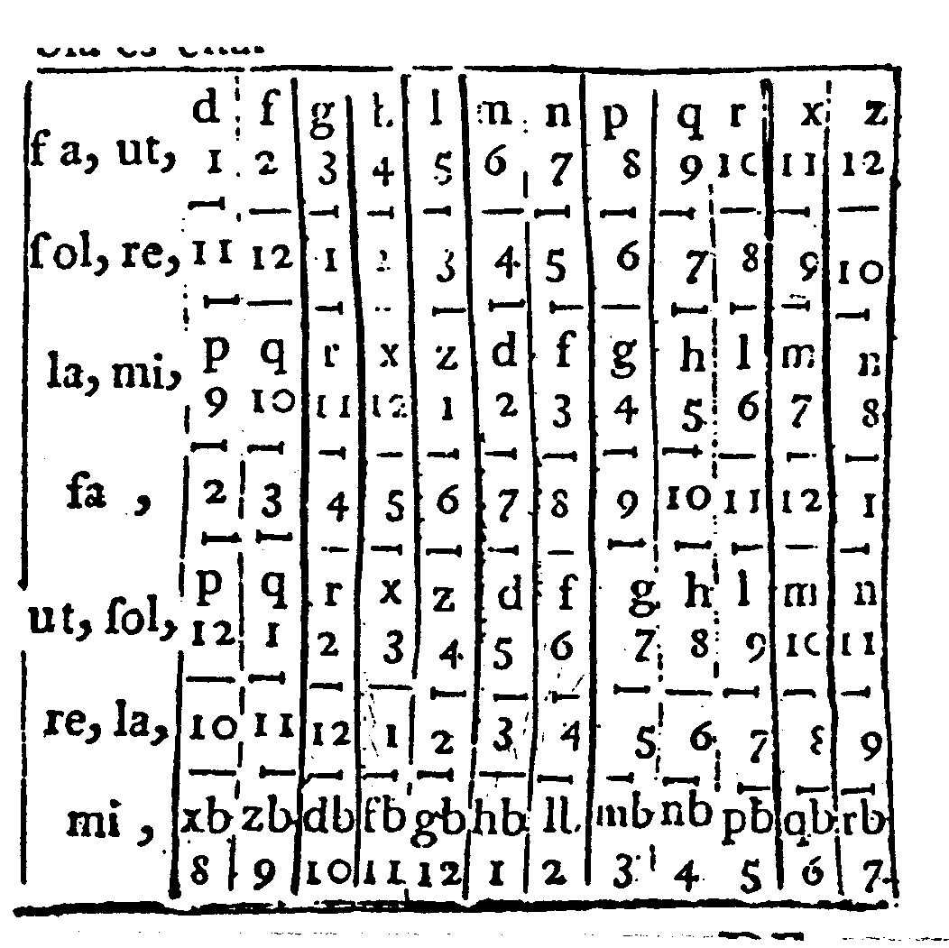

EXPLANATION OF THE TABLE

In the present table (my brother) you will find seven lines of ciphers, and by each line the solmisation syllables which correspond to them.

The ciphers are 1, 2, 3, 4, 5, 6, 7, 8, 9, 10, 11 and 12, and they represent the twelve guitar chords, 1 representing chord 1, 2 chord 2, 3 chord 3 etc.

The solmization syllable are UT, RE, MI, FA, SOL, LA, and beside these are shown all the chords which may be used to harmonize them. For example, the syllables FA, UT which are on the highest, or first line, may be accompanied by chords 1, 2, 3, etc., and we may please ourselves in chosing the chord which we like most. The syllables RE, SOL, which correspond to the second line may likewise be accompanied by any of the chords on the second line, and the same thing applies to all the other lines.

Now, bearing this in mind, when you want to cipher a piece of music, you will take the bass line and see which syllable it starts on, whether it is UT, RE, MI, FA etc. If it starts with UT, then you will find the line which corresponds to this syllable UT, and choose the chord which pleases you most out of the twelve.

If next this UT rises to FA, as for example if it were to rise from F, FA UT to B FA, B MI [i.e. rise a fourth], you will move to the line for FA, and see which chord corresponds to that which you have already chosen for UT. This you will find by looking in the table below to the right [of the solmization syllables] in the third space below [in the same column as that of the chord chosen for UT.]

Then if the note changes and rises from FA to MI, as for example if it were to rise from B FA, B MI to E, LA MI, move to the lowest line and take the chord which corresponds to the chord which you took for FA. And if after this, MI rises immediately to FA, you must take the chord which you took at the beginning, when you found yourself with the note UT because it [MI] is an octave above it, and you must therefore use the same chord.

Everything works the opposite way round when the music descends. In this way you have to carry on with all the rest of the notes, giving to each beat [or bar = compás] one or two chords, as the music demands it, because sometimes two or three chords are given to a beat, and sometimes, on the contrary, only one.

When a chord which has been given to the bass does not fit with the other parts, then you will move to the highest line, and see which letter accompanies the chord which has been given to the bass. Then moving down the table you will look for all the chords which have the same letter, and you will discover amongst them the one which does fit, because [the table is arranged in such a way that] one of these must fit all the notes in question.

And you are advised that when looking for these consonances, or coincidences, the chords on the first and third lines may be either major or minor, whilst those on the fifth line may only be major, and those on the seventh, minor, the “b’s” which are beside each letter on the lowest line indicating just that. You are also advised that when the music procedes imitatively, you must begin by ciphering the part which enters first, until such time as the bass enters.

This is what the table demonstrates and so that you may understand it better, I would like to place [here] an example in three parts, with which you will be able to see that which has previously been descibed in practice. I have decided not to include other examples, as this is a little book, and this will suffice [as a model] for other music. Even if it is in four or five parts, it will be harmonized in the same fashion.

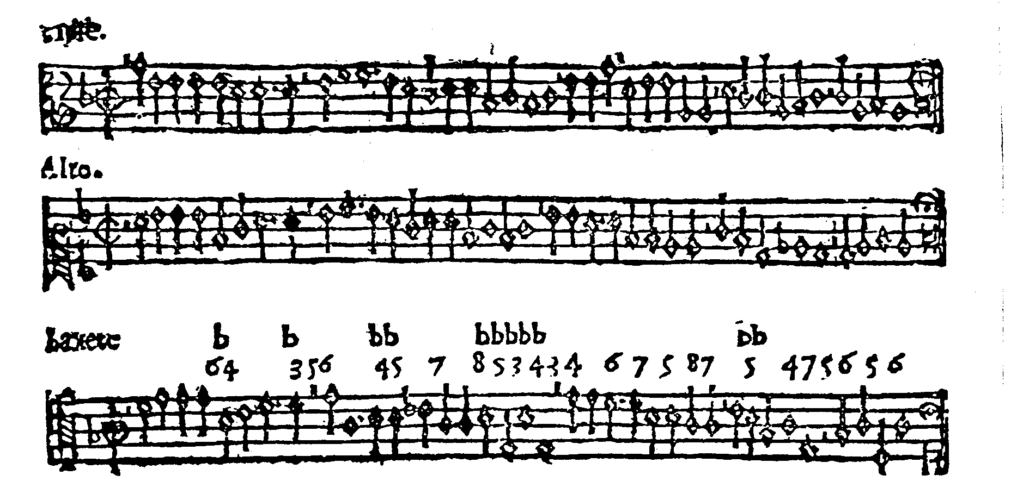
[Musical example]
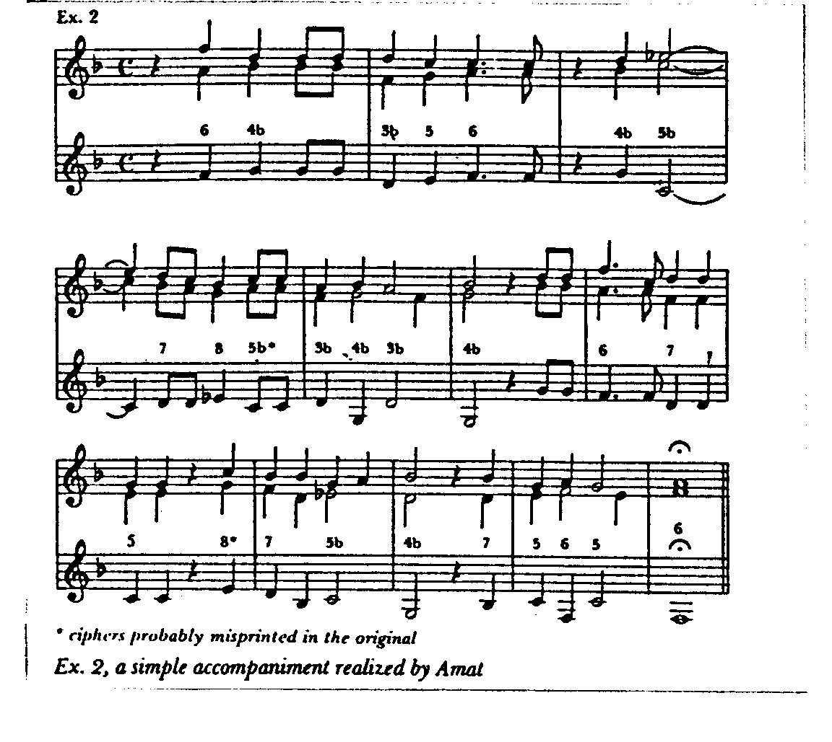

In the same way that this music has been ciphered, all other music may be ciphered, placing the chords beside the solmisation syllables, major ones without the letter b, minor ones with it.

I have chosen to cipher this music in the sixth key [i.e. using chord 6 as UT] since it was up to me to choose any of the twelve. But if you now wish to change it for the fifth [i.e. using chord 5 for UT] all you have to do is to erase all the ciphers and substitute others, retaining the same numerical difference throughout between [the original ciphers and the substituted ones].

Chord 6n placed at the beginning is erased, and in its place is put chord 5n. Then the chord 4b which follows is erased and in its place is put 3b. In this way, all the others should be altered until the end of the piece is reached, observing always this rule – that if the chord which is erased is major, that which replaces it must be major, and if it is minor, that which replaces it must also be minor.

In this fashion it is possible (as I have explained) to play this and any other music in twelve keys [using any of the twelve chords as UT].

CHAPTER 9

Deals with the guitar with seven strings [ordenes i.e. four courses]

So that those who play the four-course guitar (which has seven strings) do not blame me because I have not discussed their instrument in this little book, I have included a few little things about it in this final chapter.

The four-course guitar is tuned in the same way, has the same twelve major and minor chords, and the same notes as the five-course guitar, so that anything that is played on the five-course instrument can be played on the four-course instrument as well, and each piece of music can also be played in twelve keys. Only one difference is found, and it is this; on the five-course guitar there is one course more, which is the fifth course, but if this is removed, it is no more or less than the four-course guitar.

The way in which the chords are arranged is the same throughout except for chords 4b and 8b [actually 9b] which vary in this way. When playing chord 4b on the four course guitar, the third course is stopped at the third fret, whilst on the five-course guitar it is left unstopped. When playing chord 8b [actually 9b] on the four-course guitar, the third course is stopped at the fourth fret, whilst on the five-course guitar it is stopped at the first fret. [The third of the chord would otherwise be lacking].

Finally, anyone who wishes to play the four-course guitar should follow all the rules and the same style as for the five-course guitar which I have described, ignoring any references to the fifth course.

I have not bothered to discuss the tempo and/or metre [ayre] with which these guitars should be played, because the music itself will carry [some indication of] it with it. If the piece is in triple time [de proporción], the metre will be triple, whether it is fast [mayor] or slow [menor]. Common time [ayre=compás] may also be fast [mayor] or slow [menor], and likewise all the others [tempos or metres].

He who plays the guitar should bear in mind that the right hand is the Choir Master, and the fingers of the left hand the singers ruled and governed by him.

Laus Deo

TABLE OF THE CHAPTERS WHICH ARE CONTAINED IN THIS BOOK

Chapter 1 Which explains how many strings and frets there are on the five-course guitar, and the way of tuning them

Chapter 2 What is a chord, how many there are and how they are named

Chapter 3 Of the arrangement of all the major chords

Chapter 4 Of the arrangement of all the minor chords

Chapter 5 Of the table for knowing which finger to use to play the string and at which fret

Chapter 6 How there are no more of the major and minor chords

Chapter 7 Of the chords from which are formed all manner of pieces and how these can be played in twelve keys

Chapter 8 Of a table with which one can cipher any piece of music and play an sing it in twelve keys

Chapter 9 How the guitar with seven strings is tuned in the same way and has the same chords and the same notes at has that with nine strings

End of the Table

WITH A LICENCE

Printed in Lérida in the house of the widow Anglada, and Andreu Llorens, and at their cost.
Year of 1626.

Title page of the 1639 edition

THE FIVE-COURSE SPANISH GUITAR :

Which shows how to tune,
and how to play all the major and minor chords rasgado,
in a wonderful manner.

AND SO THAT ANY SONG CAN BE PLAYED ON IT,
a table is included, with which anyone may cipher a song,
and afterwards play, and sing it without difficulty in twelve keys;
now corrected by the author himself.

AND AT THE END MENTION IS ALSO MADE
of the four-course guitar.

AUTHOR OF THIS METHOD,
Joan Carlos Amat Doctor of Medicine.

[Illustration of a five course guitar]

WITH A LICENCE.

In Barcelona, by Lorenço Deu, before the Palace of the King, The year 1639.

Sold at the same printers.

Title page of the Joseph Brò edition c.1761.

THE SPANISH GUITAR, AND VANDOLA

in two versions, Castilian and Catalan,
which show how to tune the five course guitar,
and how to play rasgado all the major and minor chords
in an amazing fashion.

AND IN ORDER TO PLAY ON IT ANY
tune, a table is included with which
anyone may add chords to a tune without difficulty,
and afterwards play and sing it in twelve [different] keys.
And the four course guitar is also described.

[Illustration of a young woman playing the guitar]

Gerona : By Joseph Bró, Printer.

Tractat breu

BRIEF TREATISE,
AND EXPLANATION OF THE CHORDS

of the Guitar, in the Catalan Language,
adapted in this last impression of the present
work.

SO THAT NATIVES WHO
wish to learn, and do not understand
the explanation in Castilian may satisfy
their desire with this brief,
and abridged version.

[Illustration of a young woman playing the guitar]

Gerona : By Joseph Bró, Printer.

CHAPTER 1
In which is explained what are the chords of the guitar and how they may be understood written in ciphers, and the names, first, second etc of the major and minor ones.

It must be understood that the total number of perfect chords on the guitar are twenty four. (If there appear to be many more, such as those which are at the fifth, sixth etc. fret, they are only formally distinguished by us as being separate from the twenty four. [This is] because they [the chords at the fifth fret and above] have the same consonances, one to another, so that they can be made one fret above or below the others, but with the same arrangement of the fingers).

The first twelve are called major [Naturals] which are indicated by a letter n beside the number by which they are called. And the other twelve [are called] minor [b Molls], which are indicated with a letter b; the numbers are those which are found above the lines [of the tablature] and above each chord, as can be seen in the example and arrangement which follows.

[Illustration of the chords in Italian tablature]

In order to understand these chords perfectly from the manner in which they are placed, it has to be noted first of all that the five lines which pass from side to side represent the five courses of the guitar, in such a way that the lowest corresponds to the first course of the guitar, that nearest to it the second etc.

In the second place it has to be understood that the ciphers or numbers which pass through the middle of the lines represent the frets of the guitar in such a way that 1 indicates the first fret, 2 the second, 3 the third etc.

And thus in the chords written out before, on the guitar only those strings have to be stopped, and at that fret, which correspond to the lines on which the ciphers are found, preserving the relationship of the lines to the strings and of ciphers to frets as has already been described.

In order to know which fingers are convenient for stopping the strings and so that each chord has its appropriate form and arrangement, the dots which are found to the side of each cipher must be referred to. And these indicate that when the cipher has one dot beside it, the string to which it [the cipher] corresponds has to be stopped at the fret which the cipher indicates by the first finger (which is called the index finger, and is that nearest to the longest finger); when two are found it has to be stopped with the middle finger; when three are found, by the ring finger and when four are found by the little finger.
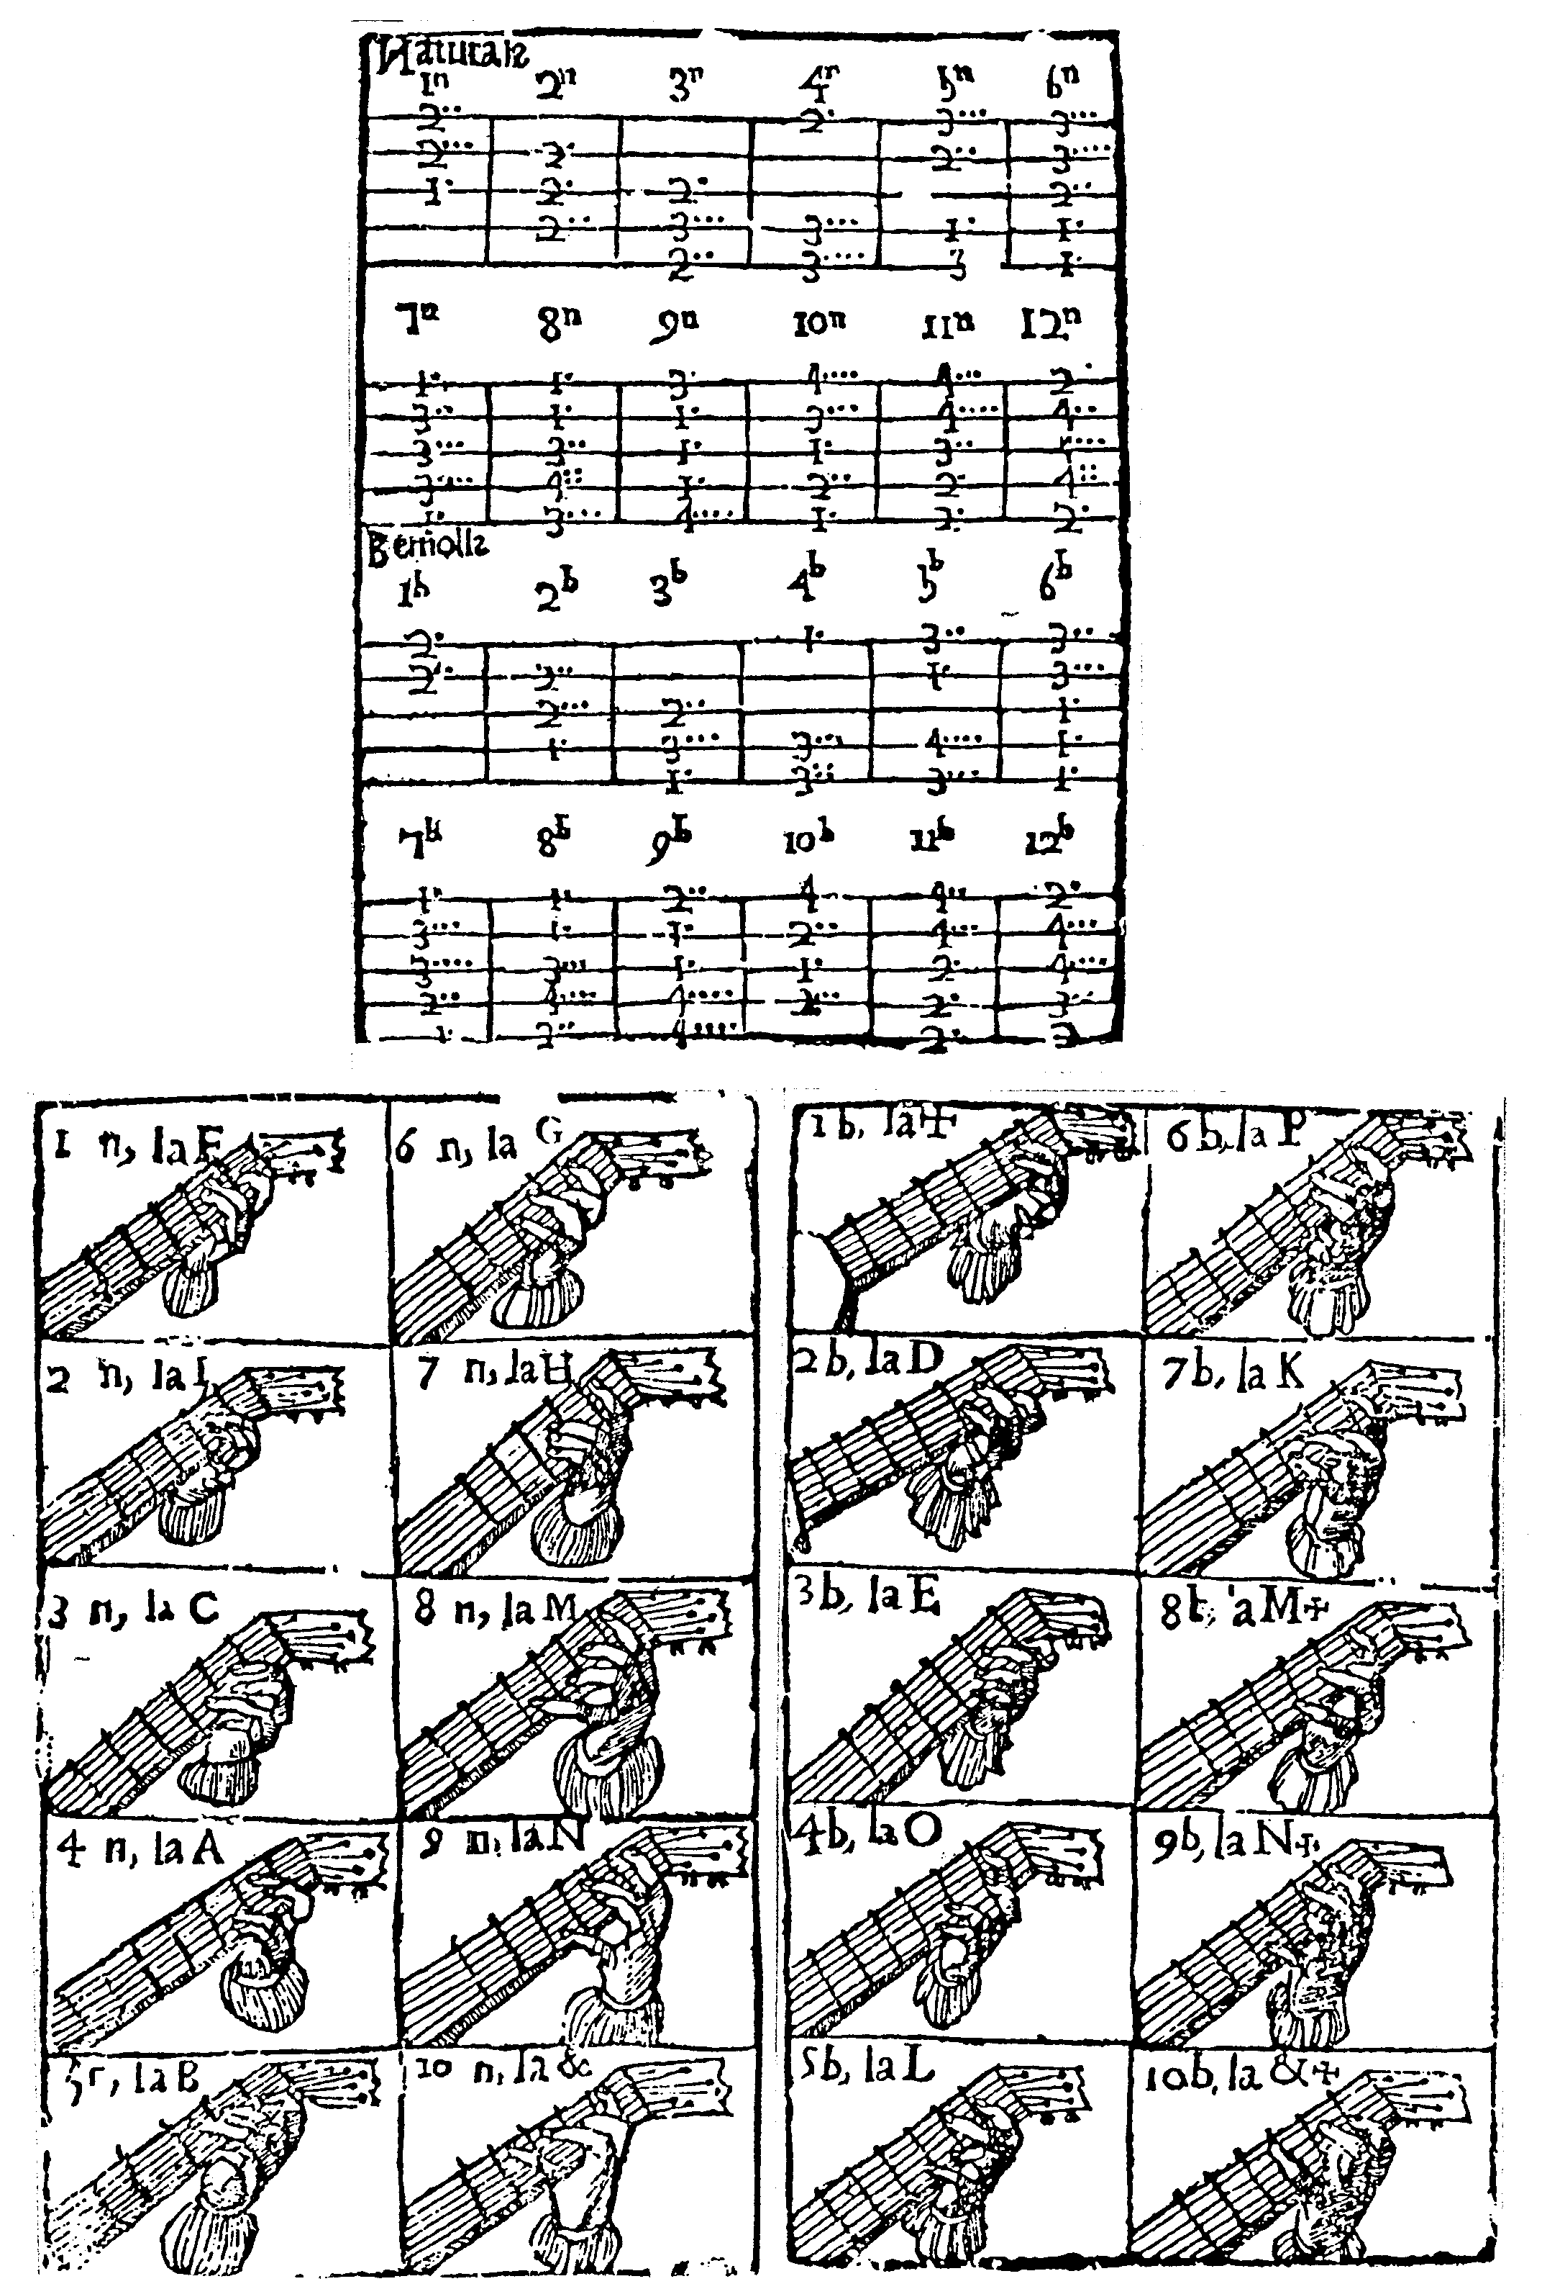

CHAPTER 2
In which the preceding chords are further explained, showing the proper form and arrangement of each chord, indicating the fingers, and strings which they have to stop and the letter name, A,B,C, which corresponds to each major and minor chord.

Because the preceding chords and illustration may be somewhat difficult, causing worry and confusion to the beginner on the guitar (to whom this work is dedicated, being solely the first rudiments and principles), the aforesaid chords, and the fingers with which they have to be formed, are set out in this present chapter with more simplicity and with evidence of the proper form and figure which is convenient for them. Example.

[Illustrations of hands stopping chords on the fingerboard]

ADVICE ON UNDERSTANDING THESE CHORDS

In these two pages of fingerboards and hands are contained all the chords of the first chapter, which are the perfect chords of the guitar. So as not to leave any trace of difficulty and so that the beginner may understand them without a teacher it must be understood

FIRSTLY, that on the fingerboard of the guitar it is sufficient to have only four frets in order to form all the essential and perfect chords, and even if there are more [frets] they are for more taste and ingenuity of playing.

SECONDLY it must be understood that these fingerboards are made up of seven lines, of which the two thickest, which are the highest and the lowest, and which are one on each side of the fingerboard, have no other function than to outline the fingerboard of the guitar; and thus, in order to form the chords one has to consider these two lines as if they had no function [no si fossen]. The remaining five thinner ones, which are those in the middle, represent the five courses of the guitar.

THIRDLY it must be understood that each fingerboard with its hand forms a perfect chord from the first chapter. Note that the first page contains the major chords and the second the minor ones just as they are named in each box.

FOURTHLY it must be understood that any chord, whether on the first or second page, may have some fingers, which although they appear to stop [the strings], in reality do not stop any string, and they are those fingers which are shown with a ring. How to know which fingers stop, and which fingers do not stop, will be seen in the explanation of each individual chord [in the following two chapters].

LASTLY it must be understood that in the corner of the box for each chord is indicated the name of the chord found in that box, in the first place by means of the numbers for the minor and major [chords] (indicating the minor ones with a b and the major ones with an n as already said), and afterwards by a letter, the name of which corresponds to the chord. This will be seen more clearly in that which follows.

CHAPTER 3
Explanation of the first page of fingerboards, which contains ten boxes, which are the ten major chords

[1n] The first box contains the first major chord, which is called F, and it is played stopping the fifth course at the second fret with the long (or middle) finger, the fourth course also at the second fret with the ring finger, and the third course at the first fret with the index (or first) finger. In this chord the little finger does not stop any course, nor are the first and second courses stopped.

[2n] The second box descending vertically contains the second major chord, which is called I; it is played stopping both the fourth and third courses firmly with the index finger at the second fret, and the second course also at the second fret with the middle finger. In this chord the ring finger and little finger do not stop any course, and the first and fifth courses are not stopped.

[3n] The third box contains the third major chord which is called C, and it is played stopping the third course at the second fret with the index finger, the second course at the third fret with the ring finger, and the first course at the second fret with the middle finger. In this chord the little finger is free, and the fourth and fifth courses are not stopped.

[4n] The fourth box contains the fourth major chord, which is called A, and it is played stopping the fifth course at the second fret with the index finger, and the second course at the third fret with the ring finger, and the first course at the third fret with the little finger. In this chord the middle finger is free, and the third and fourth courses are not stopped.

[5n] The fifth box contains the fifth major chord, which is called B, and it is played stopping the fifth course at the third fret with the ring finger, the fourth course at the second fret with the middle finger, and the second course at the first fret with the index finger. In this chord the little finger is free, and the first and third courses are not stopped.

[6n] The sixth box contains the sixth major chord, which is called G, and it is played stopping the fifth course at the third fret with the ring finger, the fourth course at the third fret with the little finger, the third course at the second fret with the middle finger and the second and first courses at the first fret with the index finger. In this chord all the fingers are used, and all the courses are stopped.

[7n] The seventh box contains the seventh major chord, which is called H, and it is played stopping the fifth and first courses at the first fret with the index finger [i.e. with a barré], the fourth course at the third fret with the middle finger, the third course at the third fret with the ring finger and the second course at the third fret with the little finger. In this chord all the fingers are used, and all the courses are stopped.

[8n] The eighth box contains the eighth major chord, which is called M, and it is played stopping the fifth and fourth courses at the first fret with the index finger, the third course at the second fret with the middle finger, and the second course at the fourth fret with the little finger and the first course at the third fret with the ring finger. In this chord all the fingers are used, and all the courses are stopped.

[9n] The ninth box contains the ninth major chord, which is called N, and it is played stopping the fifth course at the third fret with the middle finger, the fourth, third and second courses at the first fret with the index finger, and the first course at the fourth fret with the little finger. In this chord the ring finger is free, and all the courses are stopped.

[10n] The tenth box contains the tenth major chord, which is called &, and it is played stopping the fifth course at the fourth fret with the little finger, the fourth course at the third fret with the ring finger, the second course at the second fret with the middle finger and with the index finger the third and first courses are stopped at the first fret. In this chord all the fingers are used, and all the courses are stopped.

EXPLANATION AS TO WHY IN THE
two pages of fingerboards there are only ten boxes, or ten major and minor chords

The fact that there are only ten fingerboards, rather than twelve, on each of the pages which correspond to the major and minor chords may cause difficulty. It should be noted that the chords may be increased in this way. Chord 11n has the same position of the hand which 6n or G has, but set at the second fret, and chord 12n has the same position as 7n, set at the second fret. Likewise 11b has the same position of the hand which 6b or K has, but set at the second fret, and 12b the same position as 7b, set at the second fret.

CHAPTER 4

Explanation of the second page of fingerboards which contains the minor chords

[1b] On this page are found ten boxes. The first box contains the first minor chord, which is called +, and it is played stopping the fifth course at the second fret with the index finger, and the fourth course also at the second fret with the middle finger. In this [chord] the ring finger and little finger do not stop [any course] and the first, second and third courses are not stopped.

[2b] The second box descending vertically contains the second minor chord, which is called D, and it is played stopping the fourth at the second fret with the middle finger, and the third course at the second fret with the ring finger and the second course at the first fret with the index finger. In this chord the little finger does not stop [any course] and the first and fifth courses are not stopped.

[3b] The third box contains the third minor chord, which is called E, and it is played stopping the third course at the second fret with the middle finger, the second course at the third fret with the ring finger, and the first course at the first fret with the index finger. In this chord the little finger does not stop [any course] and the fourth and fifth courses are not stopped.

[4b] The fourth box contains the fourth minor chord, which is called O, and it is played stopping the fifth course at the first fret with the index finger, the second course at the third fret with the ring finger, and the first course at the third fret with the little finger. In this chord the middle finger does not stop [any course] and the fourth and third courses are not stopped.

[5b] The fifth box contains the fifth minor chord, which is called L, and it is played stopping the fifth course at the third fret with the middle finger, the fourth course at the first fret with the index finger, the second course at the fourth fret with the little finger and the first course at the third fret with the ring finger. In this chord all fingers stop [the courses] and only the third course is not stopped.

[6b] The sixth box contains the sixth minor chord, which is called P, and it is played stopping the fifth course at the third fret with the middle finger, the fourth course at the third fret with the ring finger, and the first, second and third courses all at the first fret with the index finger. In this chord only the little finger does not stop [any course] and all the courses are stopped.

[7b] The seventh box contains the seventh minor chord, which is called K, and it is played stopping both the fifth and first courses at the first fret with the index finger, the fourth course at the third fret with the ring finger, the third course at the third fret with the little finger and the second course at the second fret with the middle finger. In this chord all the fingers stop [the courses] and all the courses are stopped.

[8b] The eighth box contains the eighth minor chord, which is called M+ minor, and it is played stopping the fifth and fourth courses at the first fret with the index finger, the third course at the third fret with the ring finger, the second course at the fourth fret with the little finger and the first course at the second fret with the little finger. In this chord all the fingers stop [the courses] and all the courses are stopped.

[9b] The ninth box contains the ninth minor chord, which is called N+ minor, and it is played stopping the fifth course at the second fret with the middle finger, both the fourth and third courses at the first fret with the index finger, and the second and first courses both at the fourth fret with the little finger. In this chord the ring finger does not stop [any course] and all the courses are stopped [sic – this may be an error. The ring finger is used to stop the second course at the fourth fret in the Castilian section of the text].

[10b] The tenth and last box contains the tenth minor chord, which is called &+ minor, and it is played stopping the fifth course at the fourth fret with the little finger, the fourth course at the second fret with the middle finger, the third course at the first fret with the index finger and the second course at the second fret with the ring finger. In this chord all the fingers stop [the courses] and only the first course is not stopped.

End of the guitar [section].

FINAL CHAPTER
In which is explained the manner of tuning the vandola and how it is adjusted to the guitar

The way in which the vandola is adjusted to the guitar and the manner in which it is tuned are explained in this chapter, in order to fulfil that which is promised in the principal title of the present work. And it should be noted that the vandola with six courses is described here, because it is the more perfect form of the instrument, and better known and more widely used at this time than that with four or five courses.

In order to tune this vandola and so as to explain it with more clearly and briefly [it should be understood that] the five courses without the first course are tuned in the same way [to the same intervals] as the guitar and afterwards the unstopped first course is tuned and it is an octave from the sixth course also unstopped, or from the fourth course stopped at the second fret. Or the first course stopped at the second fret is tuned to the third course unstopped.

In order to play or tune this vandola to the [same] chord of a guitar, or a guitar to the [same] chord of a vandola, the third course of the guitar unstopped must be in unison with the fifth course unstopped of the vandola, and the fourth course of the guitar must be in unison with the sixth course of the vandola when both are unstopped, and the first course of the guitar must to be in unison with the third course of the vandola, both unstopped. Of the chords of the vandola [which are] consonant with those of the guitar it is difficult to give a rule. It is only possible to say that on the five courses, excluding the first, of the vandola, which are [tuned] to the same [intervals] as the guitar, all the chords which are formed on the guitar have the same consonances, set one chord behind those of the guitar, on the said five courses of the vandola. Thus if on the guitar chord 3n is played, on the vandola 2n will be played (and in the same way the minor chord); only the first course of the vandola is played in different manner, which if I were to explain it without having a vandola in hand would only confuse more.

For this short treatise (dear reader) I do not seek thanks, only correction and advice from whoever may understand it (to whom I submit it); only in truth to be brief, so that of the bad [there may be] less, and according to the liking which this work may find in the pleasure and benevolence of youth, I will urge myself on, moved by the spirit of love, in a more detailed work which neither the present little volume nor the shortness of time permits me. Employing myself always in things of your desire.

Farewell, and again farewell!
THE END

Salamó is a small town in the province of Tarragona.
“Natural man delights in music and rhythm” – quotation presumably from Aristotle’s Poetics.
Acis, the young shepherd, lover of Galatea.
Unidentified. Possibly the same as “cigara” – a cricket.
Although the pitch is not indicated here, the musical example at the end of Chapter 8 implies that the first course is tuned to e’.
The 1639 edition includes vacas amongst the list of pieces.
Que son fa ut is missing from 1626/27 edition but inserted in 1639 edition.
This passage is not entirely clear. In Spanish musical theory proporcion = triple time, compás = duple or common time. These could be either menor or mayor; the value of the notes in the mayor form are double those of the menor, but played twice as fast, or at least faster. I have assumed that ayre means the same as compás here.
In ediitions published in Valencia the title reads “The Spanish guitar and the vandola, in two versions, Castilian and Valencian.”
The word order of the original title is confusing, implying that there are two kinds of guitar, rather than that the book has sections in two different languages.
“in the Valencian language” in editions printed in Valencia.

